ABSTRACT

Heat exchangers are important heat & mass exchange apparatus in oil refining, chemical engineering, environmental protection, electric power generation, etc. Among different types of heat exchangers, shell-&-tube heat exchangers (STHXs) have been commonly used in industries. About 35–40% of heat exchangers are of the STHXs, & this is primarily due to the robust construction geometry as well as easy maintenance & possible upgrades of STHXs. Segmental baffles are most commonly used in conventional STHXs to support tubes & change fluid flow direction. But, conventional heat exchangers with segmental baffles in shell-side have some shortcomings resulting in the relatively low conversion of pressure drop into a useful heat transfer.

The Helix changer - a heat exchanger with shell side helical flow eliminates principle shortcomings caused by shell side zigzag flow induced by conventional baffle arrangements.

The new design reduces dead zones within the shell space. These results in relatively high (Heat transfer co-efficient/Pressure drop) & low shell side fouling.

Thus, the helix changer exhibits much more effective way of converting pressure drop into a useful heat transfer than conventional heat transfer. This project is basically gives the performance of shell & tube heat exchangers with helical baffles.

TABLE OF CONTENTS

Sr. No. | Chapter Name | Page No.
Chapter 1 | Company Profile | 1-15
1.1 | Over view of PAT | 1
 | 1.1.1 Vision | 3
 | 1.1.2 Mission | 3
 | 1.1.3 Valves | 3
1.2 | Company Organization | 4
 | 1.2.1 Overview of all Departments | 5
1.3 | Products | 6
1.4 | Heat Exchangers | 7
 | 1.4.1 Shell and Tube Heat Exchanger | 7
 | 1.4.2 Air Cooled Heat Exchanger | 7
 | 1.4.3 Fin Tube Heat Exchanger | 8
1.5 | Pressure Vessels | 8
 | 1.5.1 Column Pressure Vessel | 8
 | 1.5.2 Coded Pressure Vessel | 9
 | 1.5.3 LPG Bullets | 9
1.6 | Refrigeration & Air-conditioning Equipment | 10
 | 1.6.1 Air Handling Units | 10
 | 1.6.2 Coils | 10
1.7 | Machinery | 11
Chapter 2 | Shell and Tube Heat Exchanger | 16-29
2.1 | Introduction | 16
2.2 | Basic Parts of Shell and Tube Heat Exchanger | 17
 | 2.2.1 Tubes | 18
 | 2.2.2 Tube Sheet | 19
 | 2.2.3 Shell | 19
 | 2.2.4 Channel Cover | 20
 | 2.2.5 Pass Driver | 20
 | 2.2.6 Baffle | 20
Sr. No. | Chapter Name | Page No.
2.3 | Tema | 22
2.4 | General Classification | 24
 | 2.4.1 Fixed Tube Sheet type | 24
 | 2.4.2 U Tube type | 25
 | 2.4.3 Floating Head type | 26
 | 2.4.4 Flexible Bellows type | 27
 | 2.4.5 Kettle type Heat Exchanger | 28
2.5 | Allocation of streams in a Shell and Tube Heat Exchanger | 29
2.6 | Cost Aspect Of Heat Exchanger | 29
Chapter 3 | IDP (Industrial Define Problem) | 30-35
3.1 | Problem Statement | 30
3.2 | Introduction of Baffle | 30
3.3 | Problem affecting Performance in Shell and Tube Heat Exchanger | 31
 | 3.3.1 Fouling | 31
 | 3.3.2 Tube Vibration | 32
 | 3.3.3 Leakage | 32
 | 3.3.4 Dead Zone | 32
3.4 | Excepted Outcomes | 33
Chapter 4 | Problem Solution | 36-39
4.1 | Helical Baffle Heat Exchanger | 36
 | 4.4.1 Advantage of Helix Changer | 38
Chapter 5 | Conclusion and Future Plane | 40
5.1 | Conclusion | 40
5.2 | Future Plane | 40
 | Reference | 41

LIST OF FIGURE

Fig. No. | Figure Name | Page No.
1.1 | Inverted Pyramid Structure | 3
1.2 | Organization Structure | 4
1.3 | Shell and Tube Heat Exchanger | 7
1.4 | Air Cooled Heat Exchanger 7 | 7
1.5 | Fin Tube Heat Exchanger | 8
1.6 | Column | 8
1.7 | Vessel 9 | 9
1.8 | LPG Bullets | 9
1.9 | Air Handling Units 10 | 10
1.10 | Coils | 10
1.11 | Pro cut CNC Oxy Fuel Machine | 11
1.12 | Automatic tube to tube sheet welding M/C | 11
1.13 | Fin line Press and Die System Machine | 11
1.14 | Tube Finning Machine | 12
1.15 | Column & Boom Type Submerge Arc welding | 12
1.16 | Lathe Machine | 13
1.17 | Plate Bending Machine 15 | 14
1.18 | Radial Drilling Machine | 15
2.1 | Sectional View of Shell and Tube Heat Exchanger | 16
2.2 | Multiple shell and tube passes | 17
2.3 | Detail 3 – D view | 17
2.4 | Header plate or tube sheet | 19
2.5 | Baffle Type | 21
2.6 | Detailed view of an ex. | 23
2.7 | Fixed Tube Sheet | 24
2.8 | U – Tube Heat Exchanger | 25
2.9 | Floating Head Type Heat Exchanger | 26
2.10 | Flexible Bellows type heat exchanger [3] | 27
2.11 | Kettle Reboiler | 28
3.1 | Rod Baffle Support | 33
3.2 | Axial Flow Baffles | 34
3.3 | A Helical Baffle Shell and Tube Heat Exchanger | 35
4.1 | Helical Baffle Heat Exchanger | 36

LIST OF TABLE

Table No. | Table Name | Page No
1.1 | Specification of Vessels | 9
1.2 | Specification of Tube Fining Machine | 12
1.3 | Specification of Radial Drilling Machine | 15
2.1 | Allocation of stream | 30

CHAPTER 1: COMPNAY PROFILE

1.1 Overview of PAT

Serving the industry Since-1973

Member of:
HTRI-USA
(Heat Transfer Research, INC.)

PATEL AIRTEMP (INDIA) LIMITED (PAIL) is on of the Recognized & leading designer, manufacturer and Supplier of complete range of Shell & Tube Heat Exchanger s, HP-LP Heaters, Air Cooled Heat Exchanger, Finned Tubes, Pressure Vessels, Columns, Reactors, Tanks and Air Conditioning &Refrigeration Equipments.

PAIL is serving the Industry since 1973, which has a board of well experienced directors lead by Shri N.G. Patel, a Post Graduate Engineer of 1965 Batch having experience of more than 47 years and is well supported by four other whole time Directors In the field of designing, manufacturing.

1
The company started its operation from a small manufacturing facility at vatva – Ahmadabad in 1973.With a steady & robust growth vision of the promoters, in 1994, company has started new manufacturing unit at Rakanpur near Sola Village in Ta. Kalol, Dist. Gandhinagar, Gujarat spread over 33,400 Sq.Meter of Land. To finance the new infrastructures, PAIL came out with its Public Offering in March 1994.

The company is having a sophisticated infrastructure capable of manufacturing wide range of process Plant equipments under one roof; comparable with the best engineering companies in the country.

In November 1996, PAIL signed a contract of Technical Collaboration with M/s. Tek-Fins Inc, USA for design and manufacturing of Air Cooled Heat Exchangers. To strengthen its core competency in Thermal / Mechanical Design & for giving best value package, through optimization of Process Design, company has adopted Internationally reputed software of Heat Transfer Research Institute (HTRI), USA for Thermal Design, and PV Elite & Codecalc software by M/s. COADED Inc., USA, and Microprotol by M/s. EuResearch, France for Mechanical design, and FE Pipe Software by M/s. Paulin Research
Group, USA for FEA Analysis.

To Elevate its standard and to meet the global customer requirements, company has adopted international standard for design, manufacturing, testing & supply of process equipments. The companyhas been audited by American Society of Mechanical engineers (ASME) and has been accredited byASME “U”, “U2”, “S” & “R” Stamp. The company has also received National Board Authorization toapply “NB” Stamp on Coded equipments and register it with National Board.

PAIL is having complete range of Air Cooled Heat Exchangers, Shell & Tube Heat Exchangers, Finnedtube type heat Exchangers, Pressure Vessels and conditioning equipments such as Process Heat Exchangers, Boiler Feed Water Heaters, Air Preheaters, Inter coolers, After coolers, Oil Coolers, LPG Bullets Storage Tanks, Air Cooled & Water cooled Condensers, Flooded & DX Shell & Tube Type Chillers, AHUs & FCUs etc…

The company has attained the position of one the leading suppliers of above equipments to majorPower Plants, Refineries, Petrochemical Units, Chemical Plants, Fertilizer Units, Nuclear Power Plants, Pharmaceuticals, Textiles, POY/PFDY/Staple Fiber Plants, Department of Atomic energy, Heavy Water Plants and to all leading Consulting Firms in India and several part of the world.

2
1.1.1 Vision

An organization’s purpose is the “Why” of its existence. It’s not what it does as much as what it is striving to accomplish. It is a statement of the greater good it is attempting to achieve. It answers the question: “Why are we here?” and helps give clarity and focus to each person in the organization. It is the yardstick by which decision are measured.

1.1.2 Mission

An organization’s Mission is the “What” of an organization. It is a definition of what the company does to achieve its stated Purpose. It beings to Define the core proficiencies of a business and helps Keep it focused on achieving its Purpose.

Customers

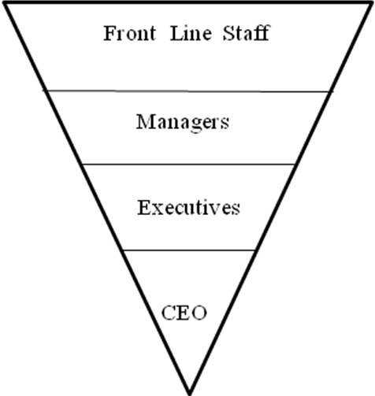

Figure 1.1 Inverted Pyramid Structure

1.1.3 Valves

An organization’s set of values is the “How” of an Organization. It defines what an organization most values in the execution of its Mission. It’s not an all encompassing list of possible values as much as a statement of what the organization most values in its people and their conduct. It defines behaviors and culture within an organization. It helps set guidelines of what is and is not acceptable.

3
1.2 Company Organization

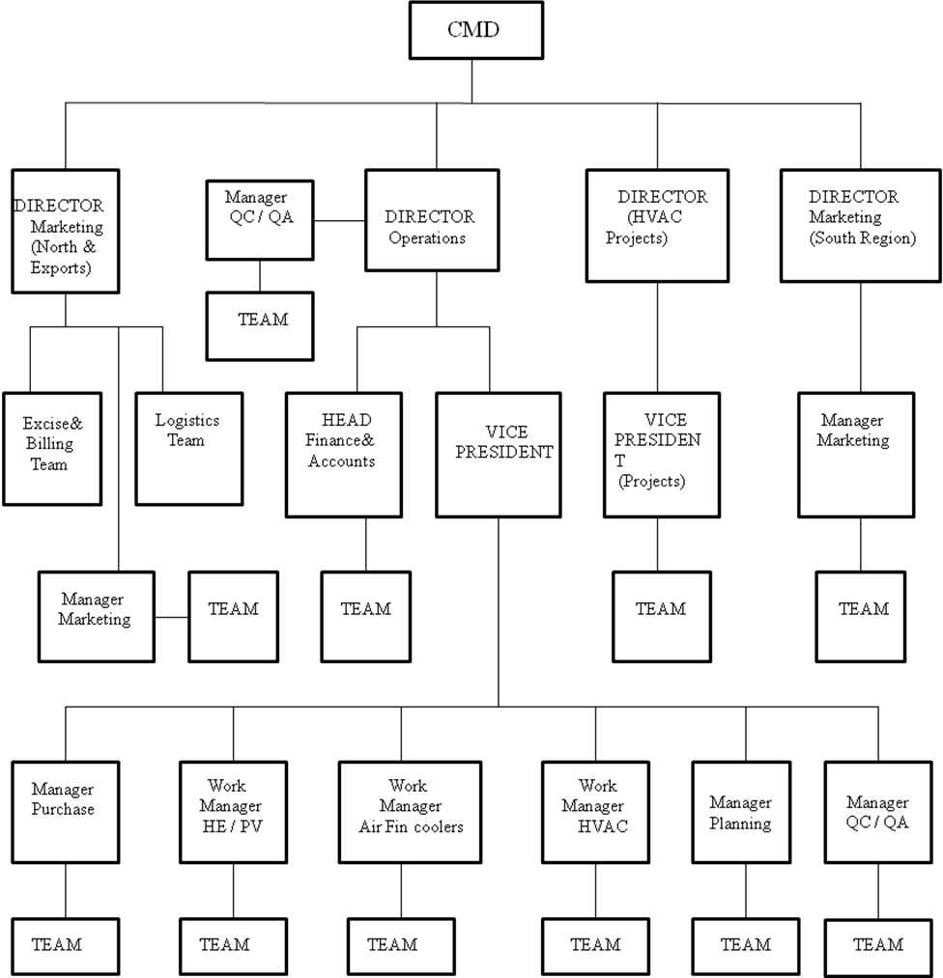

Figure 1.2 Organization Structure

4
1.2.1 Overview Of All Departments

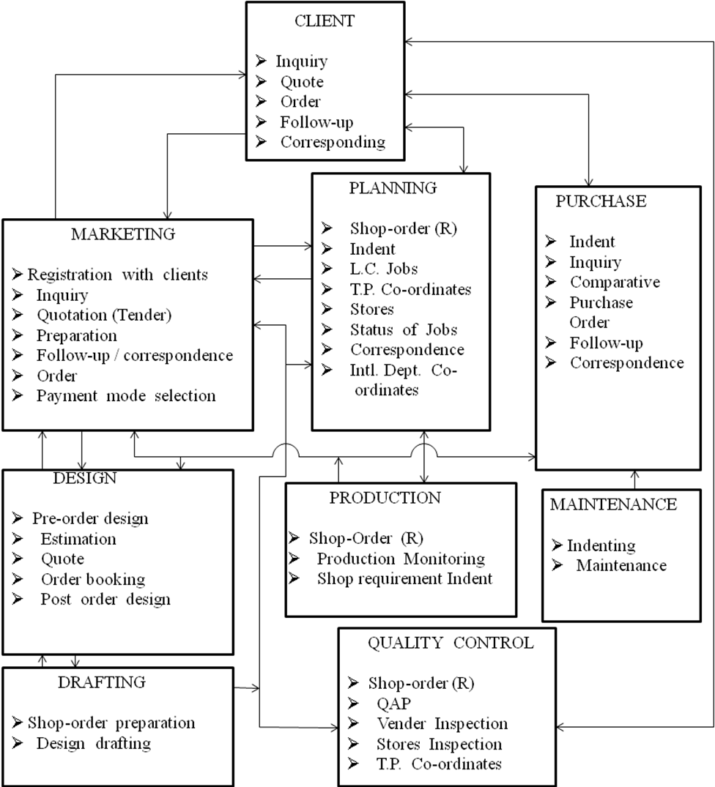

5
1.3 Products

1) Heat Exchanger

i.) Shell & Tube Heat Exchanger
ii.) Air Cooled Heat Exchanger
iii.) Finned Tube Heat Exchanger
iv.) Bare Tube Heat Exchanger
v.) HP-LP Heat Exchanger

2) Pressure Vessel

i.) Coded Pressure Vessel
ii.) Column Pressure Vessel
iii.) LPG Bullet

3) Refrigeration & Air-conditioning Equipment

i.) Air Handling Units – Fan coil Units
ii.) Coils
a)DX Cooling Coils
b)Chilled Water Cooling Coils
c)Brine Cooling Coils
d)Steam Coil air Preheaters
e)Hot water Heater
iii.) Window Air Conditioners
iv.) Split Air Conditioners
v.) Ductable Split Air Conditioners
vi.) Air cooled Package Air Conditioners

6
1.4 Heat Exchangers

1.4.1 Shell and Tube Heat Exchanger
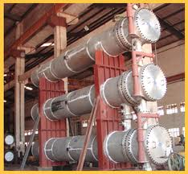

Fig 1.3 shell and Tube Heat Exchanger

PAT is a complete facility to design ( Thermal and Mechanical ) and manufactures complete range of shell and Tube Heat Exchanger For cooling, condensing and Heating application.

The manufacturing facility is well supported by in house design codes and welding development department to establish manufacturing process for any new material.

1.4.2 Air Cooled Heat Exchanger

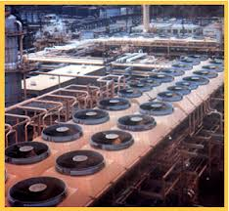

Fig 1.4 Air Cooled Heat Exchanger

Being Pioneer in Finned Tube Heat Exchanger, PAT entered into Technical Collaboration with M/s. Tetfin Inc. For Air-cooled Heat Exchanger PAT established all required facilitiesike “Spiral Finning Machine ( from McElroy-USA ), Header Welding and Drilling Facilities, Destructive and non-destructive testing facility and assembly shop at heavy handling facilities.

PAT’s Air Cooled Exchangers are now approved by leading consultants like ELI, UHDE, JHSE, NPCIL, etc…

7
1.4.3 Fin Tube Heat Exchanger

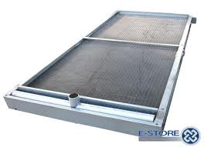

Fig 1.5 Fin Tube Heat Exchanger

- For AIR / GAS cooling, AIR / GAS heating
- Mod of Tube: CS, SS, Cu, AL, Admiralty Brass, Cupro-nickle
- Moc of Tubes: Al, Cu, tinned copper, galvanized CS and SS

1.5 Pressure Vessels

1.5.1 Column Pressure Vessel

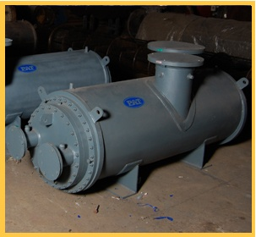

Fig 1.6 Column

With most Sufficient Handling and fabrication facilities PAT has acquired vide acceptance in industry for manufacturing of coded Vessel & Columns. Pat has hand on experience to manufacture Vessel & Column From almost all material of construction, used in process Plant industries. PAT has worked with Carbon Steel, Stainless Steel, Monel, High Corrosion resistant Steel like (Duplex SS317L and copper Alloy ), Cladded Steel. PAT’s designing and manufacturing also has critical approvals like IBR (Chief Controller of Steam, Smoke, & Nuisance ),CCOE ( for explosive fluid ) and so on.PAT has already manufactured vessels for critical fluids like Helium, LPG, Ammonia, Nitrogen, Hydrogen High Pressure Air, Nuclear Waste, etc…

8
1.5.2 Coded Pressure Vessel

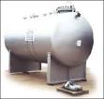

Fig 1.7 Vessel

TYPE: Horizontal & Vertical cylindrical Type Pressure Vessels, Strong
Tank of LPG Ammonia and Ethylene Oxide & Underground
Petroleum Tank, Road Tankers, Tank Wagons, Low Temperature
Process Equipment, Chlorine Tonner

Shell Diameter: 300MM to 6000MM

Thickness: 5MM to 40MM

Design Code: *IS-2825, BS-5500, *ASME Section-VIII, Div. – 1, API 650,
IS803, *IBR, *SMPV Rules 1981

Table 1.1 Specification of Vessels

1.5.3 LPG - bullets

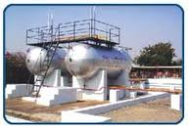

Fig 1.8 LPG Bullets

- 150 MT CAPACITY

- CCE APPROVAL

- SA-537 CL-I

- UPTO 6000mm DIAMETER AND 100mm THICK

9
1.6 Refrigeration & Air-conditioning Equipment

1.6.1 Air Handling Units
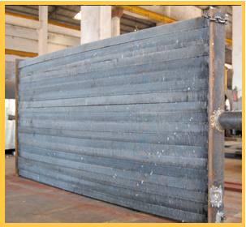

Fig 1.9 Air Handling Unit

Single skin as well as double skin sectionalized construction with cooling Coil/steam Heating coil / Brine Coil, Damper, Filter, Humidification and Reheating Arrangement etc…

1.6.2 Coils

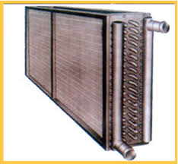

Fig 1.10 Coils

- DX Cooling Coils

- Chilled Water Cooling Coils

- Brine Cooling Coils

- Steam Coil Air Pre-Heaters

- Hot Water Heater

Fin Materials – Aluminum, Copper, Stainless steel,
Tube Material – Copper, Stainless Steel, Cupronickel Carbon Steel.

10
1.7 Machinery

(1) Pro cut CNC Oxy Fuel Machine

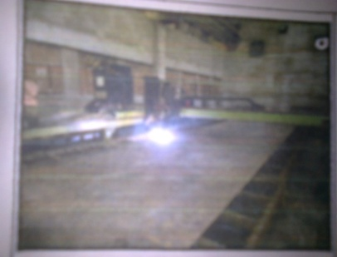

Fig 1.11 Pro cut CNC Oxy Fuel Machine

Cutting Width – 3150 mm, Cutting Length - 14000mm

Cutting Thk. – Cs – 300 mm, Ss – 50 mm. Area: 3 mtr X 14 mtr

(2) Automatic tube to tube sheet welding M/C

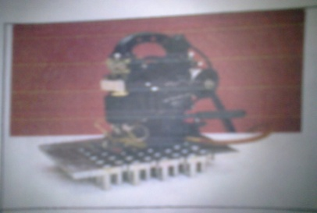

Fig 1.12 Automatic tube to tube sheet welding M/C

(3) Fin line Press and Die System Machine

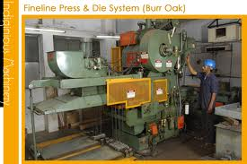

Fig 1.13 Fin line Press and Die System Machine

Fin line press and die system of burr oak, USA make for making sine wave slit fins.

11
(4) Tube Finning Machine

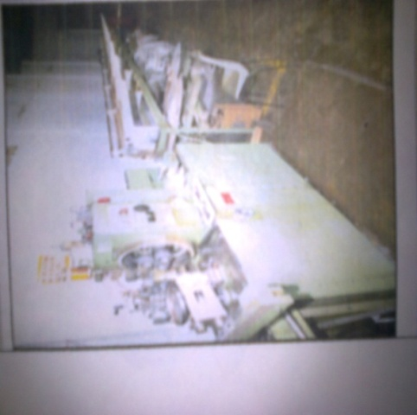

Fig 1.14 Tube Finning Machine

“McElroy – USA “finned tube machine

Tube size: 14.29 mm to 50.8 mm dia & Material C.S, S.S & Alloy steel length up to
12.2 mtr & above with special attachment.

Fin Type: Imbedded & Wrapped On (“g” type & “L” type Material – Aluminum
Alloy, C.S., C.U.

Fin Size: Height 6.35 mm to 20.5 mm Pitch 5 to 13 FPI

Table 1.2 Specification of tube Fining Machine

(5) Column & Boom type Submerge Arc welding machine

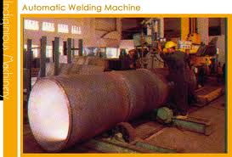
Fig 1.15 Column & Boom Type Submerge Arc welding M/C

Having 10 MT Roller bed with 1 power unit and idler unit for welding up to max. Shell dia 4000 mm.

12
(6) Lathe Machine

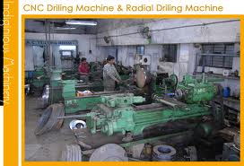

Fig 1.16 Lathe Machine

JMT, RAJKOT or JMK, BATALA or ANIL, RAJKOT

Capacity of 1000 mm OD x 800 mm Long

Capacity of 700 mm OD x 800 mm Long

Capacity of 1100 mm OD x 1100 mm Long

Capacity of 1200 mm OD x 1000 mm Long

Capacity of 1000 mm OD x 1400 mm Long

Capacity of 500 mm OD x 1200 mm Long

Capacity of 350 mm OD x 2800 mm Long

Capacity of 200 mm OD x 650 mm Long

Capacity of 500 mm OD x 1200 mm Long

TUBE FINNING Lathe Machine Capacity of 6 meter Long

13
(7) Plate Bending Machine

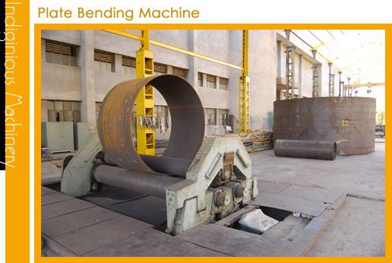

Fig 1.17 Plate Bending Machine

SS – 304L & SS – 316L– 82 mm in 3000 mm width

SS – 304 & SS – 316 – 75 mm in 3000 mm width

CARBON STEEL – 70 mm in 3000 mm width 80 mm in 2000 mm width.

This machine has Section Bending, conical bending Facility and even Roll position indicators

HIMALAYA make Plate Bending Machine having capacity to roll

CARBON STEEL – 30 mm in 3000 mm width

14

(8) Radial Drilling Machine

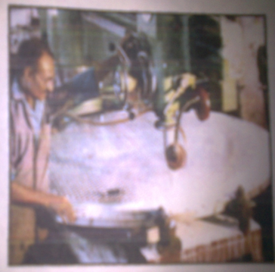

Fig 1.18 Radial Drilling Machine

Capacity to drill up to maximum Hole radius thickness. | 65 X 11 X 70175
 | 65 X 1500 X 200
 | 65 X 2350 X 300
Capacity to drill up to maximum Hole radius | 50 X 900
 | 60 X 1000
 | 40 X 700
 | 30 X 650
 | 20 X 600

Table 1.3 Specification of Radial Drilling Machine

15
CHAPTER 2: SHELL AND TUBE HEAT EXCHANGER

2.1 Introduction

It consists of a bundle of circular tubes mounted in a cylindrical shell. One of the fluids flow through the bundle of tubes. The other fluid is forced through the shell and flows over the outside surface of tubes. The flow condition become more complicated in this exchanger. Fig. 2.1 shows a shell and tube exchanger with one shell pass and tube pass. Baffle are generally installed in the exchanger in order to generate turbulence in the shell side fluid and to promote a cross flow component in the velocity of this fluid relative to tubes. As a result of this effects, a higher heat transfer coefficient for the outer tube surface is obtained. The tubes may be arranged in a regular and staggered fashion. This type of exchanger is commonly used for liquid to liquid heat transfer.

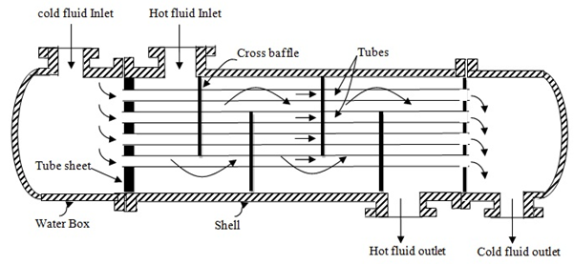

Fig 2.1 Sectional view of Shell and Tube Exchanger

In order to increase the overall heat transfer. Multiple shell and tube passes are used. The two fluids traverse the exchanger more than once ( i.e. multi pass ). By suitable heater design, the fluid within the tubes can be made to traverse back and forth from one ends of the shell to other. Similarly, by suitable shell and heater design, the flow inside the shell may be traversed more than once. Fig 2.2 shows the heat exchanger with multiple shell and tube passes. This type of exchanger is preferred due to its cost of manufacture, easy to repair and maintain and reduce thermal stresses due to expansion facility.

16
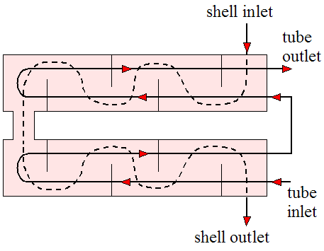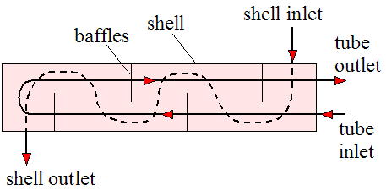

Fig 2.2(a) 2 tube passes and Fig2.2 (b) 4 tube passes and
1 shell passes 2 shell passes

Fig 2.2 Multiple shell and tube passes

2.2 Basic parts of shell and tube heat exchanger

While there is an enormous variety of specific design features that can be used in shell and tube Exchangers, the number of basic components is relatively small. They are soon in figure below

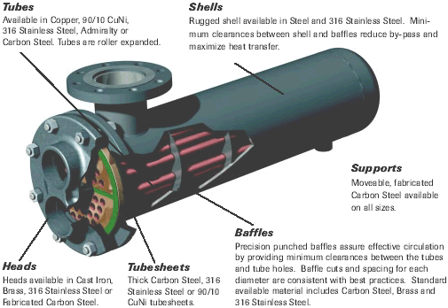

Fig 2.3 Detail 3D view

17
2.2.1 Tubes

The tubes are the basic component of the shell and tube exchanger, providing the heat transfer surface between one fluid flowing inside the tube and the other fluid flowing across the outside of the tubes. The tubes maybe seamless or welded and most commonly made of copper or steel alloys. Other alloys of nickel titanium or aluminum may also be required for specific applications.

The tubes may be either bare with extended or enhanced surfaces on the outside. A typical fin need surface tube. Extended or enhanced surface tubes are used when one fluid has a substantially lower heat transfer coefficient than the other fluid. A doubly enhanced tube that is fins on both the sides of the tubes are used to reduce size and cost of exchanger.

2.2.1.1 Tube Dimensions And Parameters

1) Tube Wall Thickness

It is standardized in terms of BIRMINGHAM WIRE GAGE (BWG)
Small tube diameters (8 to 15mm) for greater area to volume density, and
large diameters are for condensers and boilers.

2) Tube Outside Diameter
The most common diameters are 5/8, 3/4, and 1 inch
Smaller the tubes, more compact and better heat transfer coefficient
Larger tubes are more rugged and easy to clean.
For mechanical cleaning the smallest practical size is 19.05 mm and for
chemical cleaning smaller sizes can also be preferred.

3) Tube Length
Longer the tubes then fewer tubes are needed and less complicated tube
sheet. Also the Shell diameter increases resulting in lower cost
Typically 8, 12, 15, 20 foot lengths.
Shell diameter to tube length ratio should be 1/5 OR 1/15
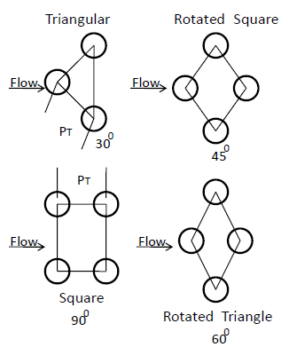

18

4) Tube Layout And Pitch
Tube layout is characterized by the included angles between tubes. Square
and equilateral are the standard configurations.
Triangular (3o) – good for heat transfer and surface area per unit length,
compact, smaller shell and stronger header.
Square (90 or 45) – for mechanical cleaning and 90 layout – lowest heat
transfer and pressure drop
For identical in tube pitch and flow rates, layout in decreasing order of
heat transfer coefficient are 30, 45, 60, 90
Pitch ratio is 1.25 < PT/do < 1.5

2.2.2 Tube Sheets

The tubes are held in place by inserted into holes in the tube sheet and there either expanded into grooves cut into the holes or welded to the sheets where the tube protrudes from the surface. The tube sheet is usually a single round plate of metal that has been suitably drilled and grooved to take the tubes (in the desired pattern), the gaskets, the spacer rods, and the bolt circle where it is fastened to the shell. However where mixing between the two fluids (in the event of leaks where the tube is sealed into the tube sheet) must be avoided, a double tube sheet is used as shown :
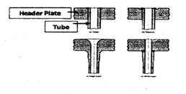

Fig 2.4 Header plate or tube sheet

The space between the tube sheets is open to the atmosphere so any leakage of either fluid should be quickly detected. The tube sheet in addition to its mechanical requirements must withstand corrosive attack by both fluids and must be electronically compatible with the tube and tube sheets are sometimes are made with a thin layer of corrosion resisting alloy metallurgic ally bonded to one side.

2.2.3 Shell

The shell is simply the container for the shell side fluid, and the nozzles are the inlet and exit ports. The shell normally has a circular cross section and is commonly made by rolling a metal plate of the appropriate dimensions into a cylinder and welding the longitudinal joint ( rolled shells )

19
Small diameters shell ( up to 24 inches ) can be made by cutting the pipe of the desired diameter to correct length (piped shells). The roundness of the shell is important in fixing the maximum diameter Of the baffles that can be inserted and therefore the effect of shell to baffle leakage.

Shells are made out of low carbon steel wherever possible for reasons of economy, thought other alloys can be used and are used when corrosion or high temperature strength demands are to be met.

2.2.4 Channel Covers

The channel covers are round plates that bolt to the channel flange and can be removed for tube inspection without disturbing the tube side piping. In smaller heat exchanger bonnets with flange nozzles or threaded connections for tube side piping’s are often used.

2.2.5 Pass Divider

A pass divider is needed one channel or bonnet for an exchanger having two tube side passes, and they are needed in either the channels or bonnets for an exchanger having multipasses. If the channels or bonnets in either are cast, then the dividers are integrally cast and then faced to give a smooth bearing surface on the gasket between the divider and the tube sheet. If the channels are rolled from plate or built up from pipe, the divider are welded in place.

The arrangement of the dividers in multipass exchanger arbitrary, the usual intent to provide the same number of tubes in each pass to minimize the number of tubes lost from the tube count, to minimize pressure drop, to minimize leakage, adequate bearing surface for the gasket and minimize fabrication complexity

2.2.6 Baffles

Baffles serve two functions: Most importantly they support the tubes in proper orientation during assembly and operation and prevent vibration of the tubes caused by flow induced eddies and secondly they guide the shell fluid back and forth across the tube field, increasing velocity and heat transfer coefficients.

The most common baffle shape is single segmental sheared off must be less than half the diameter in order to ensure that adjacent baffles overlap at least full row. For liquid flows on the shell side the baffle cut of 20 to 25 percent of the diameter is common; for gas flow 40 to 50 percent in order is acceptable in order to minimize pressure drop.

20
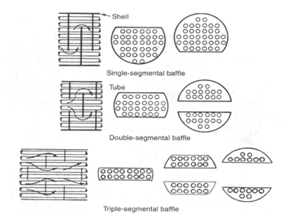
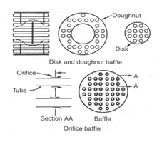

Fig 2.5 Baffle type

The baffle spacing should be correspondingly chosen to make the free flow areas through the window ( the area between the baffle edge and shell ) and across tube bank roughly equal.

For many high velocity gas flows, single segmental baffle leads to high double segmental baffle are generally used
For sufficiently large units it is possible to go for triple segmental and ultimately strip and rod baffles, the important being to insure that every tube is positively constrained at periodic to prevent sagging and vibration.

21
2.3 Tema

Standards of the Tubular Exchanger Manufacturer Association (Tema)

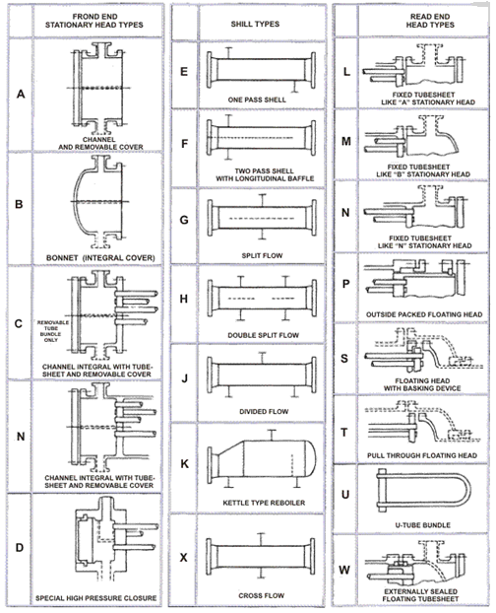

Type designation shall be by letters describing stationary head, shell ( omitted for bundles only ), and rear head in the order as depicted in the above figure Split ring floating head exchanger with removable channel and cover, single pass shell 23-1/4 (519mm) inside diameter with tubes 16’ (4877m) long.

22

TYPE AES
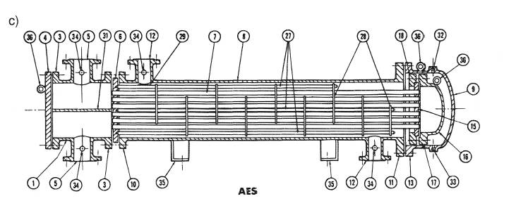
1. Stationary Head – Channel | 21. Floating Head Cover – External
2. Stationary Head – Bonnet | 22. Floating Tube sheet Skirt
3. Stationary Head Flange – Channel | 23. Packing Box
or Bonnet
4. Channel Cover | 24. Packing
5. Stationary Head Nozzle | 25. Packing Gland
6. Stationary Tube sheet | 26. Lantem Ring
7. Tubes | 27. Tlerods and Spacers
 | 28. Transverse Baffles or Support
8. Shell | Plate
9. Shell Cover | 29. Impingement Plates
10. Shell Flange – Stationary Head End | 30. Longitudinal Baffle
11. Shell Flange – Rear Head End | 31. Pass Partition
12. Shell Nozzle | 32. Vent Connection
13. Shell Cover Flange | 33. Drain Connection
14. Expansion Joint | 34. Instrument connection
15. Floating Tube sheet | 35. Support Saddle
16. Floating Head Cover | 36. Lifting Lug
17. Floating Head Cover Flange | 37. support Bracket
18. Floating Head Cover device | 38. Weir
19 Split Shear Ring | 39. Liquid Level Connection
20. Slip – on Backing Flange | 40. Floating Head Support

Fig 2.6 detailed view of Heat Exchanger.

23
  - General Classification

    - Fixed tube sheet type
A fixed – tube sheet heat exchanger has straight tubes that are secured at both ends to tube sheets welded to the shell. The construction may have removable channel covers ( e.g., AEL ), bonnet-type channel covers ( e.g., BEM ), or integral tube, tube sheets ( e.g., NEN ). The principal advantage of the fixed tube sheet construction is its low cost because of its simple construction. In fact, the fixed tube sheet is the least expensive construction type, as long as no expansion joint is required. Other advantages are that the tubes can be cleaned mechanically after removal of the channel cover or bonnet, and that leakage of the shell side fluid is minimized since there are no flange joints.

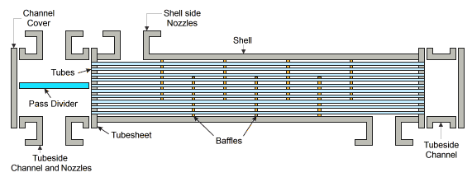

Fig 2.7 Fixed tube sheet

A disadvantages of this design is that since bundle is fixed to the shell and tube cannot be removed, the outside of the tubes cannot be cleaned mechanically. Thus, its application is limited to cleaned services on the shell side. However, if a satisfactory chemical cleaning program can be employed, fixed – tube sheet construction may selected for fouling services on the shell side. In the event of a large differential temperature between the tubes and the shell, the tube sheet will be unable to absorb the differential stress, thereby making it necessary to incorporate joint. This takes away the advantage of low cost a greater extent.

24
    - U TUBE type
As the name implies, the tubes of a U – tube heat exchanger as shown in the figure are bent in the shape of a U. There is only one tube sheet in a U tube heat exchanger. However, the lower cost for the single tube sheet is offset by the additional costs incurred for the bending of the tubes and the some what larger shell diameter ( due to the minimum U – bend radius), making the cost of a U – bend heat exchanger comparable to that of a fixed tube sheet exchanger.

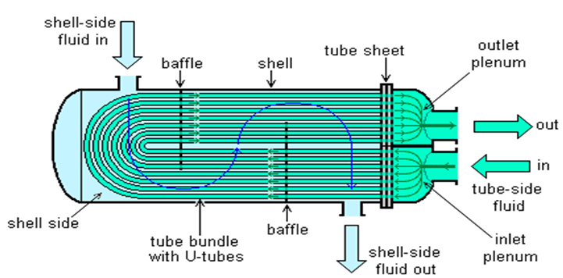

Fig 2.8 U – Tube Heat Exchanger

The advantages of a U – bend heat exchanger is that because one end is free, the bundle can expand or contract in response to stress differentials. In addition, the outsides of the U – tube construction is that the inside of the tubes cannot be cleaned effectively, since the U – bends would required flexible – end drill shafts for cleaning. Thus, U – tube heat exchangers should not be used for services with a dirty fluid inside tubes.

25
    - Floating head type

The floating – dome heat exchanger is the most versatile type of STHE, and also the costliest. In this Design, one tube sheet is fixed relative to the shell, and the other is free to “float” within the shell.
This permits free expansion of the tube bundle, as well as cleaning of both the insides and of the tubes. Thus, floating – head SHTES can be Used for services where both the shell side and the tube side fluids are dirty – making this the standard construction type used in dirty services, such as in petroleum refineries. There are various types of floating – dome construction. The two most common are the pull – through with backing device (TEMA S) and pull – through (TEMA T) designs. The TEMA S design shown in the figure is the most common configuration in the chemical process industries (CIP). The floating – head cover is secured against the floating tube sheet by bolting it to an ingenious split backing ring.

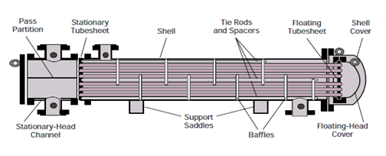

Fig 2.9 Floating head type heat exchanger

This floating – head closure is located beyond the end of the shell and contained by a shell cover of a larger diameter. To dismantle the heat exchanger, the shell cover is removed first, then the split backing ring, and then the floating dome cover, after which the tube bundle can be removed from the stationary end. In the TEMA T construction, the entire tube bundle, including the floating – head assembly, can be removed from the stationary end, since the shell diameter is larger than the floating – head flange. The floating dome cover is bolted directly to the floating tube sheet so that a split backing ring is not required. The advantages of this construction is that the tube bundle may be removed from the shell without removing either the shell or the floating dome cover, thus reducing maintenance time. This design is particularly suited to kettle reboilers having a dirty heatingmedium where U –tubes cannot be employed. Due to the enlarged shell, this construction has the highest cost of all exchanger types.

26
2.4.4 Flexible bellows type.

Heat exchanger shell bellows are used on fixed tube sheet heat exchangers. Bellows deflection is only axial and can be either extension or compression depending on the differential expansion of shell and tubes. This type of heat exchanger is used when a considerable amount of thermal expansion is observed on the shell side. In most cases the tubes are hotter than the shell, moreover tube materials is sometimes high alloy, i.e. Stainless steel or nickel alloy, which expands about 50% more than carbon steel. Design of heat exchangers is covered by the TEMA I standards and ASME sec VIII. Div I.

Heat exchanger shell bellows can be heavy wall flanged and fluid bellows. Design of such Bellows is covered by ASME Sec VIII Div I, Appendix CC. Heavy wall bellows are rugged, generally having a wall thickness equal or near to the shell well. Because of material thickness, no cover is necessary. The disadvantages is that a lot of fluid can be trapped in these corrugations and a drain is sometimes required. Those bellows are formed by wielding flanged and fluid plates together, thus creating 1, 2, or 3 U – shaped corrugations. ASME Code inspection and U – 2 stamp is required.

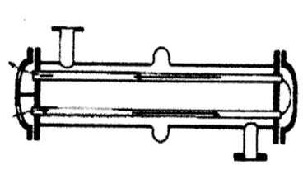
Fig 2.10 Flexible Bellows type heat exchanger [3]

Heat exchanger shell bellows can also be thin wall multi – convolution bellows, ring reinforced for higher pressures. Thin wall bellows have no circumferential welds. For this reason a higher fatigue life is expected. These bellows are more compact in OD than heavy well bellows. Design of the thin wall bellows is covered by ASME Sec VII Div I mandatory Appendix 26. Thin wall bellows can be formed by expanding mandrel, roll forming or hydraulic forming. An external cover is required for these bellows to protect against mechanical damage. Code inspection and U – 2 stamp is required.

Either heavy wall or thin wall bellows can be designed to give a satisfaction service by calculation. It should be remembered that the hydrostatic pressure and load ( Pa load ) must be carried by the tubes which act in essence as tie rods.

27
2.4. 5 Kettle type Heat Exchanger

In addition to heating up or cooling down fluids in just a single phase, heat exchanger can be used either to heat a liquid to evaporate ( or boil ) it or used as condenser to cool a vapor and condenser it to a liquid. In chemical plants and refineries, reboilers used to heat incoming feed for distillation towers are often heat exchangers.

Power plants which have steam – driven turbines commonly use heat exchangers to boil water into steam. Heat exchangers or similar units for producing steam from water are often called boilers or steam generators.

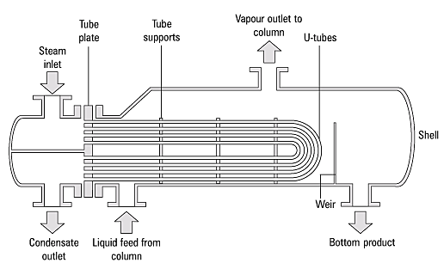

Fig 2.11 Kettle Reboiler

In the nuclear power plants called pressurized water reactors, special large heat exchangers which pass heat from the primary ( reactor plant ) system to the secondary ( steam plant ) system, producing steam from water in the process, are called steam generators. All fossil – fueled and nuclear power plants using steam – driven turbines have surface condensers to convert the exhaust steam from the turbines into condensate (water ) for re – use.

28

2.5 Allocation of streams in a Shell and Tube Heat Exchanger

There are generally four considerations which exert strong influence upon which choice will result in the most economical exchanger.

No Condition Shell Side Tobe side Comments

1 One of the fluid is at Low preessure High pressure So only the tube and
High pressure fluid fulid tube sheet are to be
designed to withstand
high pressure and shell
is light in construction.

2 Corrosion Non corrosive Corrosive As this makes it easy to
fluid fluid use shell of any material

3 Fouling Any fluid Any fluid As the phenomenon of
fouling is domonate
everywere and its consi-
derations have to be
taken care of

4 Low heat transfer Fluid with Fluid with This is done so that the
coefficient lower heat higher heat extended surface may be
transfer transfer used to reduce the total
coefficient coefficient cost of heat exchanger.

Table 2.1 Allocation of stream

2.6 Cost Aspect Of Heat Exchanger

The cost of a shell and tube exchanger is composed of the costs of the individual components (shell, tubes and so on ), plus assembly cost. The cost of each component is the sum of the material cost, plus gross fabrication ( e.g. rolling of shell ), plus machining. The final price to the customer will also include engineering and other overheads, the fabricators profit and shipping. Some of these e.g., the profit are proportional to the total cost, while shipping is nearly proportional to the total weight.

29
CHAPTER 3: IDP (INDUSTRIAL DEFINE PROBLEM)

3.1 Problem Statement

Heat transfer is considered as transfer of thermal energy form physical body to another. heat transfer Co – efficient and Pressure drop are the most important parameters to be measured as the performance and efficiency of the shell and tube heat exchanger. The developments of shell and tube exchangers on better conversion of pressure drop into heat transfer by improving the conventional baffle design or using the Helical Baffle.

3.2 Introduction of Baffle

Shell & tube heat exchangers (STHXs) are widely used in many industrial areas, such as power plant, chemical engineering, petroleum refining, food processing, etc. More than 35-40 % of heat exchangers are of the shell & tube type due to their robust geometry construction, easy maintenance & possible upgrades. Rugged safe construction, availability in a wide range of materials, mechanical reliability in service, availability of st&ards for specifications & designs, long collective operating experience & familiarity with the designs are some of the reasons for its wide usage in industry.

Baffle is an important shell side component of STHXs. Besides supporting the tube bundles, the baffles form flow passages for the shell side fluid in conjunction with the shell. The most commonly used baffles is the segmental baffle, which forces the fluid in a zigzag manner, thus improving the heat transfer but with a large pressure drop penalty. This type of heat exchanger has been well developed & probably is still the most commonly used type of the shell & tube heat exchanger. The major draw backs of the conventional shell & tube heat exchangers with segmental baffles are threefold: firstly it causes a large side pressure drop; secondly it results in a dead zone in each component between 2 adjacent segmental baffles, leading to an increase of fouling resistance; thirdly the dramatic zigzag flow pattern also causes high risk of vibration failure on tube bundle. To overcome the above mentioned drawbacks of the conventional segmental baffle, a number of improved structures were proposed for the purposes of higher heat transfer coefficient, low possibility of tube vibration & reduced fouling factor with a mild increase in pumping power.However, the principal shortcomings of the conventional segmental baffle still remain in the above-mentioned studies, even though the pressure drop across the heat exchanger has been reduced to some extent. A new type of baffle, called helical baffle, provides further improvement.

30

3.3 Problems affecting Performance on shell and tube heat exchanger

The main problems affecting the performance are usually due to one of the following:

(i) Fouling
(ii) Tube vibrations
(iii) Leakage
(iv) Dead Zones

3.3.1 Fouling

This can be generally defined as the precipitation of unwanted material within the heat exchanger over time which hamper the performance.
The principal types of fouling encountered in process heat exchangers include:
• Particulate fouling
• Corrosion fouling
• Biological fouling
• Crystallization fouling
• Chemical reaction fouling
• Freezing fouling

In the case of corrosion, the surfaces of the heat exchanger can become corroded as a result of the interaction between the process fluids and the materials used in the construction of the heat exchanger. The situation is made even worse due to the fact that various fouling types can interact with each other to cause even more fouling. Fouling can and does result in additional resistance with respect to the heat transfer and thus decreased performance with respect to heat transfer. Fouling also causes an increased pressure drop in connection with the fluid flowing on the inside of the exchanger

To improve the performance of fouled heat exchangers requires that the tubes be cleaned periodically. Tube cleaning procedures for shell and tube heat exchangers are performed off-line, the most frequently chosen and fastest method being mechanical cleaning. Among other off-line methods is the use of very high pressure water but, since the jet can only be moved along the tube slowly, the time taken to clean a heat exchanger can become extended. Chemicals are also used for the off-line cleaning of heat exchanger tubes. Several mildly acidic products are available and will remove more deposit than most other methods; but it is expensive, takes longer for the operation to be completed, and the subsequent disposal of the chemicals, an environmental hazard, creates its own set of problems.

31
3.3.2 Tube vibrations

Another problem that often arises in connection with the use of heat exchangers is tube vibration damage. Tube vibration is most intense and damage is most likely to occur in cross flow implementations where fluids flow is perpendicular to the tubes, although tube vibration damage can also occur in non cross flow (i.e. axial) implementations in the case of very high fluid velocities. Vibration may be eliminated by reducing velocities, decreasing the unsupported span or, in some cases, by altering the method of fixing or pinning the ends of the unsupported span.
This problem can cause significant damage to the exchanger if within high limits.

3.3.3 Leakage

Sometimes the fluid of the tube side can leak to shell side or vice versa, This problem can cause huge production loss. Leaks may develop at the tube to tube sheet joints of fixed tube sheet exchangers because differential thermal expansion between the tubes and the shell causes overstressing of the rolled joints. Or, thermal cycling caused by frequent shutdowns or batch operation of the process may cause the tubes to loosen in the tube holes. Floating heads or U-bend exchangers would be considered first for this type of service. If a fixed tube sheet unit is required, an expansion joint will be specified. An exchanger that will be thermally cycled two or three times a day will require superior mechanical construction such as the strength welding of tubes to the tube sheet, complete inspection of the shell and channel welds during fabrication. Welding the tubes to the tube sheets does not guarantee that a leak will not occur as sometimes weld failure due to porosity in the welds or just one poorly welded tube out of the hundreds of welds can cause a leakage. The use of double tube sheets to minimize the chances of leakage between the tube side and shell side can be a good solution to the problem. Nevertheless, double tube sheet can cause considerable maintenance problems because the outboard and inboard tube sheets may be subjected to considerably different process temperatures and this can have differential expansion between the tube sheets resulting in bending the tubes

3.3.4 Dead Zone

Areas that have the flow to minimal or even non existent and usually produce poor heat transfer and can lead ultimately to excessive fouling.
Existing shell and tube heat exchangers suffer from the fact that they must typically use baffles to maintain the required heat transfer. This, however, results in “dead zones” within the heat exchanger where flow is minimal or even non existent. These dead zones generally lead to excessive fouling. Other types of heat exchangers may or may not employ baffles. If they do, the same increased fouling problem exists. Further, in heat exchangers fitted with baffles, for example, the cross flow implementation results in the additional problem of potential damage to tubes as a result of flow induced vibration. In the case of such damage, processes must often be interrupted or shut down in order to perform costly and time consuming repairs to the device.

32
3.4 Expected Outcomes

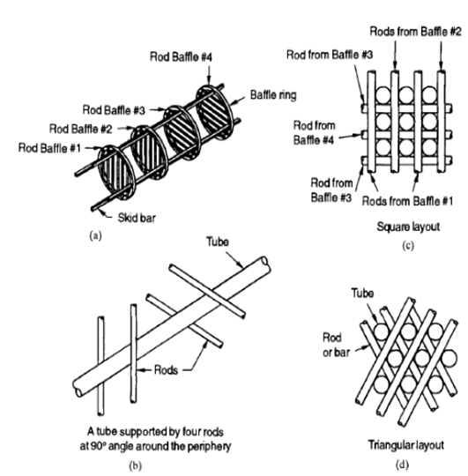

(a) four rod baffles supported by skid bars (no tubes shown)
(b) A tube supported by four rods at 90⁰ angles around the periphery
(c) A square layout of tubes with rods
(d) A triangular layout of tubes with rod

Fig 3.1 Rod Baffle Supports

(1) Some of these problems can be eliminated by modifying the shell side design to achieve axial or longitudinal flows; one construction with rod baffles is shown in Fig. 3.1. Such designs require different ways to support the tubes and may virtually eliminate the flow induced tube vibration problem.

33
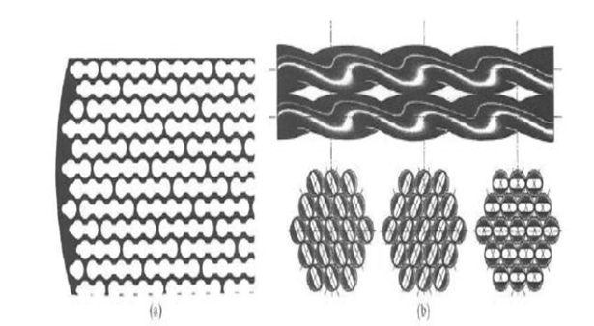

- Axial flow baffle.
- A Twisted tube exchanger.

Fig 3.2 Axial Flow Baffle

(2) Usually heat transfer rate per unit pressure drop is high in such designs; but on the absolute scale, both heat transfer rate and pressure drops are low. As a result, the exchanger usually ends up with a relatively large shell length-to-diameter ratio. In addition to rod and NEST baffle types, several new designs have been developed to induce axial flows, as shown in Fig. 3.2. Figure 3.2(a) shows a design with a full circle baffle with extra space for shell side fluid flow. Figure 3.2(b) delineates a design with twisted flattened tubes that would yield about 40percent higher heat transfer coefficient than the conventional shell-and-tube exchanger for the same pressure drop. Plain tubes may be interspersed between twisted tubes for greater design flexibility.

34
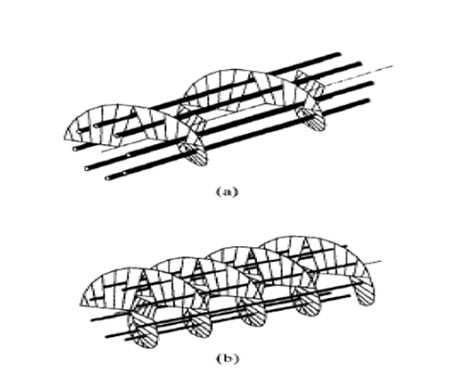

- Single Helix.
- Double Helix.

Fig 3.3 A Helical baffle Shell and Tube Heat Exchanger

(3)An alternative to conventional and axial flow shell-and tube exchangers is an exchange with helical shell side flow. It can be either a single-helix baffle, as shown in Fig. 3.3(a), or a double-helix baffle as shown in Fig. 3.3(b). There are several variations of angled baffle exchangers available commercially. The helical flow reduces the shell side flow turning losses and fouling tendency compared to a conventional shell-and-tube exchanger, but introduces radial variations in shell side mass flow rate and temperature variations that can be overcome by a radial variation in the tube pitch design.

35
CHAPTER 4: PROBLEM SOLUTION

4.1 Helical Baffle Heat Exchanger

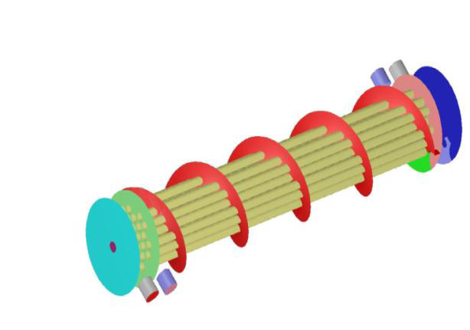

Fig 4.1 Helical Baffle Heat Exchanger

The concept of helical baffle heat exchangers was developed for the first time in Czechoslovakia. The Helical baffle heat exchanger, also known as Helix changer, is a superior shell-and-tube exchanger solution that removes many of the inherent deficiencies of conventional segmental-baffle exchangers. Helical baffle heat exchangers have shown very effective performance especially for the cases in which the heat transfer coefficient in shell side is controlled or less pressure drop and less fouling are expected. It can also be very effective, where heat exchangers are predicted to be faced with vibration condition. Quadrant shaped baffle segments are arranged at an angle to the tube axis in a sequential pattern that guide the shell side fluid to flow in a helical path over the tube bundle. Helical flow path of the shell-side fluid can also be achieved by a continuous helix shaped baffle running throughout the length of the shell and tube heat exchanger.

The helical flow provides the necessary characteristics to reduce flow dispersion and generate near plug flow conditions. It also ensures a certain amount of cross flow to the tubes to provide high heat transfer coefficient. The shell-side flow configuration offers a very high conversion of pressure drop to heat transfer.

36
- The Helix changer design provides:-

1. Enhanced Heat transfer performance/ Shell-side pressure drop ratio.

2. Reduced fouling characteristics.

3. Effective protection from flow-induced tube vibrations.

4. Lower capital costs, reduced operating costs, lower maintenance costs and
consequently, significant lower total life cycle costs.

5. For existing plants, the Helix changer design helps to increase the capacity while
lowering maintenance cost, plot space and energy costs.

- It is better to consider the Helix changer option when investigating the following:-

a) Plant upgrade with replacement tube bundles.

b) Capacity expansion with limited plot space.

c) Reduction of fouling problems and frequent downtime.

The performance of helix changer depends on helix angle which determines pressure drop on shell side, i.e. pumping power required. The heat transfer per unit pressure drop is a good metric for comparing the performance. We know that heat exchangers are widely used equipments in various mechanical, chemical, power generation and refrigeration industry. The present well established process design trend requiring high degree of heat recovery usually results in installing a larger heat exchanger area. However adding a few more heat exchangers causes an increase in pressure loss together with a greater pumping power requirement.

On the shell side the conventional segmental baffles exhibit rather high-pressure difference to produce sufficiently high heat transfer rate. Therefore fresh look into the baffle arrangement is needed. So, use of helical shaped baffles is proposed.

The fluid flow pattern, particularly within the shell, may significantly influence the heat exchanger efficiency. The development of shell and tube exchanger focuses on better conversion of pressure drop into heat transfer by improving the conventional baffle design.

37
4.1.1 Advantages of Helix changer

1. Thermal & Hydraulic Performance

Elimination of the shell-side back and forth flow path with a more unidirectional flow yields a much higher heat transfer coefficient per unit of pressure drop. Typically, heat transfer coefficients are 40% higher for the same pressure drop or, conversely, pressure drops are halved for the same heat transfer coefficient. Moreover, the tube-side swirl induced flow enhances the coefficients by an amount similar to that of twisted tape or tabulator inserts in a plain round tube. The overall effect of this is a substantial reduction of heat transfer area for a twisted tube exchanger compared with a conventional exchanger for the same duty. Alternatively, significant improvements in the performance of an existing exchanger can be achieved by replacing a conventional bundle with a Twisted Tube bundle.

2. High Thermal Effectiveness

The closer approach to pure plug flow on the shell-side means that designs achieving higher thermal effectiveness, more .typical of plate type exchangers, are possible with Twisted Tube exchangers.

3. Lower Fouling & Cleaning ability

The elimination of dead spots on the shell-side and the increased turbulence, both on the shell-side and the tube-side results in reduced fouling. Particulate fouling is reduced by the scouring action. Other types of fouling such as scaling and chemical reaction products are prevented by the removal of hot spots. Fouling characteristics are therefore, more typical of those found in plate exchangers rather than shell and tube type exchangers. The lower shell side pressure drop for a given flow means that higher velocities are possible, thereby reducing clogging and plugging with fibrous materials. Should fouling occur, the twist alignment in the twisted tube exchanger provides cleaning lanes even though the bundle is constructed using triangular pitch tube layout. Hence, the cleaning ability of a conventional square pitch layout is combined with heat transfer area density of a triangular layout.

4. Vibration Elimination

Flow induced vibration can occur in conventional exchangers although special precautions such as “no tubes in window” are available to overcome the problem by providing more tube support. The most damaging vibration arises from fluid-elastic instability that can lead to damage within a few hours of operation. The possibility of such vibration in twisted tube exchangers is completely eliminated by axial flow and because the tubes are supported approximately every two inches along the tube length. Clearly, there is some cross-flow at the inlet and outlet regions but good tube support effectively mitigates this potential for failure. Further, the cleaning lanes provide additional smooth paths with a flow entering and exiting the bundle.

38
5. Cost Saving on Total Life Cycle Basis

Surface savings, lower fouling and consequently higher service life of tube bundles. Lower shell side pressure drop saves operating costs when using the Helix changer designs. Longer run lengths with helical baffles translates into lower maintenance costs and longer operating life of tube bundles saves the disposal costs during the life span of the heat exchanger units. As a result, in new installations, the Helix changer option significantly lowers the Total Life Cycle Costs of the heat exchanger banks.

6. Improving Plant Run Length

Helix changer heat exchanger with its low fouling characteristics offers much longer run length as compared to a conventionally baffled heat exchanger in identical service. The drop in performance over an operating cycle is much slower in services.

39

CHAPTER 5: CONCLUSION AND FUTURE PLAN

5.1 Conclusion

(1) Use of helical baffles in heat exchanger reduces shell side pressure drop, pumping cost, size, weight, fouling etc. as compare to segmental baffle for new installations. The helix changer type heat exchangers can save capital cost as well as operating and maintenance cost and thus improves the reliability and availability of process plant in a cost effective way.
(2) For the helical baffle heat exchangers, the ratios of heat transfer coefficient to pressure drop are higher than those of a conventional segmental heat exchanger. This means that the heat exchangers with helical baffles will have a higher heat transfer coefficient when consuming the same pumping power.
(3) It can be concluded that proper baffle inclination angle will provide an optimal performance of heat exchangers

  - Future Plan

Design of Helical Baffle Shell and Tube Heat Exchanger.

40
Reference

Website
- www.Wikepedia.com
- www.Patelairtemp.com
- Heat Exchanger Types And Theory, http://www.bin95.com/
Book
- A Text Book of Heat and Mass Transfer Authorized by R Yadav
- Financial Report of PATEL AIRTEMP INDIA Ltd. , 2011
(3) COMPANY MANUAL and Broaches, Patel Airtemp (PAT), 2010

41

